

**EXPERIMENT NO 3**

Trushant Rathod

COMPS 18

**Experiment no 3:***Evaluation of postfix Expression using stack ADT*

**Aim:** *Implementation of Evaluation of Postfix Expression using stack ADT*

**Objective:**

1. *Understand the use of stack*
2. *Understand importing an ADT in an application program*
3. *Understand the instantiation of stack ADT in an application Program*
4. *Understand how the member function of an ADT are accessed in an application program*

**Theory***:To evaluate a postfix expression we can use a stack. Iterate the expression from left to right and keep on storing the operands into a stack. Once an operator is received, pop the two topmost elements and evaluate them and push the result in the stack again.*

**Algorithm:**

*Step 1: If a character is an operand push it to Stack.*

*Step 2: If the character is an operator. Pop two elements from the Stack. ...*

*Step 3: Step 1 and 2 will be repeated until the end has reached.*

*Step 4: The Result is stored at the top of the Stack, return it.*

*Step 5: End.*

**Code :**

#include<stdio.h>

int stack[20];

int top = -1;

void push(int x)

{

stack[++top] = x;

}

int pop()

{

return stack[top--];

}

int main()

{

char exp[20];

char *e;

int n1,n2,n3,num;

printf("Enter the expression :: ");

scanf("%s",exp);

e = exp;

while(*e != '\0')

{

if(isdigit(*e))

{

num = *e - 48;

push(num);

}

else

{

n1 = pop();

n2 = pop();

switch(*e)

{

case '+':

{

n3 = n1 + n2;

break;

}

case '-':

{

n3 = n2 - n1;

break;

}

case '*':

{

n3 = n1 * n2;

break;

}

case '/':

{

n3 = n2 / n1;

break;

}

}

push(n3);

}

e++;

}

printf("\nThe result of expression %s = %d\n\n",exp,pop());

return 0;

}

**Output:**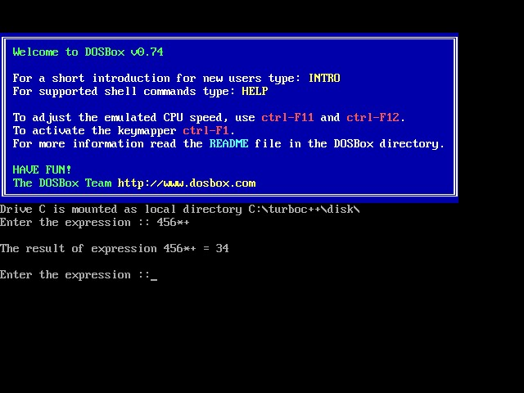

**Conclusion :** From the above output we can conclude evaluation of postfix expression stack by using adt.